IQAC – SATYA INSTITUTE OF TECHNOLOGY AND MANAGEMENT

**1.4.2 FEEDBACK ACTION TAKEN REPORT**

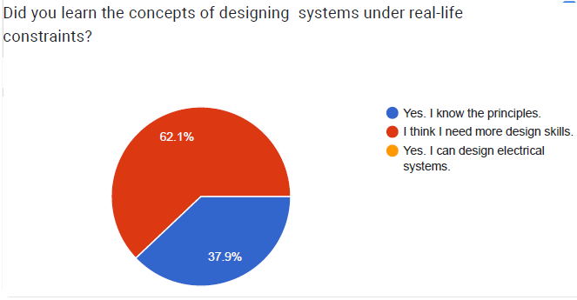

Action Taken:

1. Open ended problems are posed to make the students think.
2. Encouraged the students to participate in Community Service Projects.
3. Arranged several industrial visits.

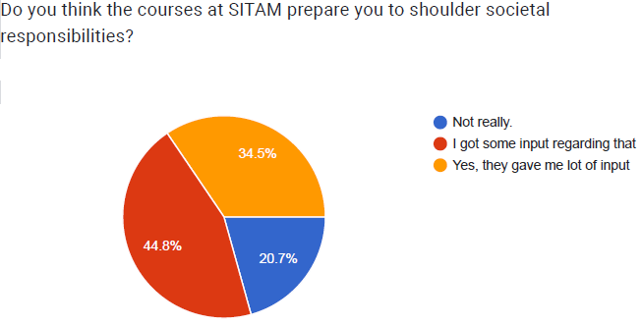

Action Taken:

1. Included professional ethics and human values as a course
2. Encouraged the students to do team work by assigning the some projects

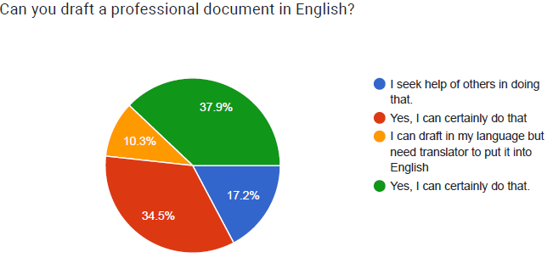

Action Taken:

1. Conducted workshops in paper writing

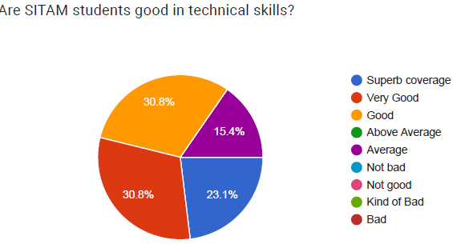

Action Taken:

* 1. Organized more workshops to improve the technical skills
  2. Provided value-added courses as part of extra-curriculum activity

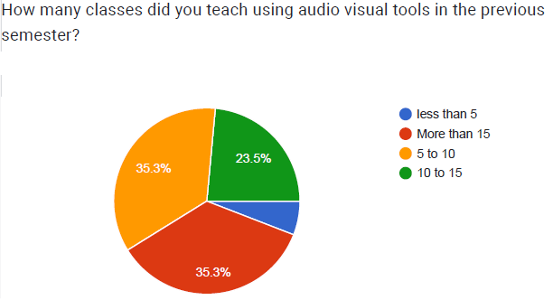

Action Taken

1. Provided interactive digital boards